SOLUTION ARCHITECTURE DIAGRAM
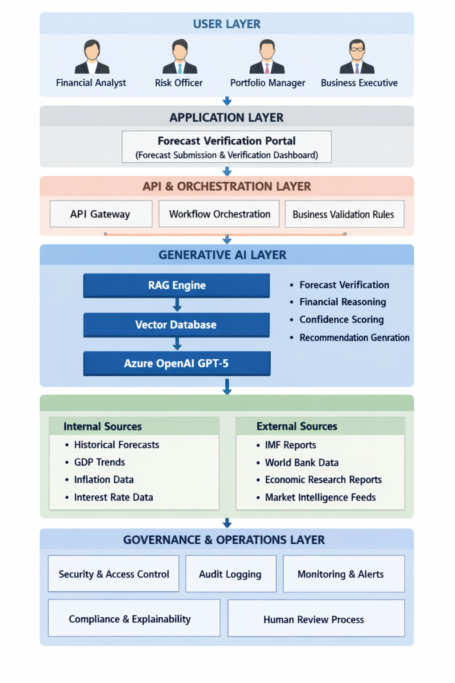
User Layer
Business users such as Financial Analysts, Risk Officers, Portfolio Managers, and Executives interact with the system to submit forecasts and review validation results.
Application Layer
Provides a user-friendly portal for forecast submission, report generation, and decision-support dashboards.
API & Orchestration Layer
Acts as the control layer that manages requests, applies business validation rules, and coordinates interactions between data sources and AI services.
Generative AI Layer
The core intelligence layer of the solution.
- RAG Engine retrieves relevant financial information.
- Vector Database stores indexed financial knowledge.
- Azure OpenAI GPT-5 analyzes forecasts, performs reasoning, identifies risks, and generates recommendations.
Data Layer
Provides trusted financial and economic information used to validate forecasts.
Internal sources include historical forecasts and financial indicators. External sources include economic reports, market intelligence, and public financial datasets.
Governance & Operations Layer
Ensures security, compliance, auditability, monitoring, and human oversight for AI-generated outputs.

End-to-End Request Flow
Step 1
A Financial Analyst submits a financial forecast through the Forecast Verification Portal.
Step 2
The request is routed through the API & Orchestration Layer, where business validation rules are applied.
Step 3
The RAG Engine searches the Vector Database for relevant historical forecasts, economic reports, and market intelligence.
Step 4
The retrieved information is combined with the submitted forecast and sent to Azure OpenAI GPT-5.
Step 5
The LLM performs financial reasoning, validates the forecast, identifies potential risks, and generates recommendations.
Step 6
The solution calculates a confidence score and determines the forecast risk level.
Step 7
A verification report is generated containing:
- Confidence Score
- Risk Assessment
- Supporting Evidence
- Recommended Forecast Range
- AI Insights
Step 8
The results are displayed to the user through the portal.
Step 9
All activities are logged and monitored to support governance, compliance, and audit requirements.

